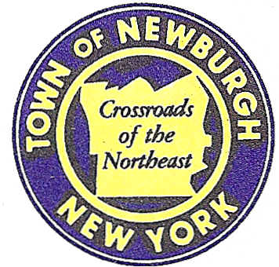

TOWN OF NEWBURGH
_______Crossroads of the Northeast __________________________
OLD TOWN HALL
308 GARDNERTOWN ROAD NEWBURGH, NEW YORK 12550

PLANNING BOARD
JOHN P. EWASUTYN, CHAIRMAN
TELEPHONE 845-564-7804
FAX 845-564-7802
E-MAIL: planningboard@townofnewburgh.org

PLANNING BOARD AGENDA

JUNE 18, 2015

*PLEASE NOTE: The Planning Board Meeting will start at 7:00 P.M. and all Applicants/Representatives
are to be present at that time. The Meeting will be held in the Meeting Room of Town Hall, located at
1496 Route 300, Newburgh NY.*

- Sprint (2015-11)  7 Meadow Hill Road  Section 60, Block 3, Lot 35.1  Zone: IB  Rep: Daniel M. Laub, Esq.  Cuddy & Fedder LLP  445 Hamilton Avenue, 14th Floor  White Plains, NY 10601 | WIRELESS MODIFICATION APPLICATION
- Westport Management (2015-12)  Gardnertown Road  Section 47, Block 1, Lot 70  Zone: R-1  Rep: Mercurio-Norton-Tarolli-Marshall  45 Main Street  Pine Bush, NY 12566 | INITIAL APPEARANCE  4 LOT SUBDIVISION
- DLE Holdings, LLC (2015-13)  5310 Route 9W  Section 23, Block 1, Lot 1  Zone: B  Rep: John D. Fuller, P.E.  4 South Street  Port Jervis, NY 12771 | INITIAL APPEARANCE  SITE PLAN
- Budget Inn (2015-05)  Route 9W  Section 27, Block 2, Lot 21.2  Zone: B  Rep: Medenbach & Eggers, P.C.  4305 US Highway 209  Stone Ridge, NY 12484 | PROPOSED ADDITION  SITE PLAN
- Hampton Inn & Suites and Restaurant (2014-16)  Route 17K & Crossroads Court  Section 95, Block 1, Lot 45.12  Zone: IB  Rep: Maser Consulting  1607 Route 300, Suite 101  Newburgh, NY 12550 | SITE PLAN / ARB
*WORK SESSION: Project Readiness Discussion scheduled for 5:30 p.m. in the Meeting Room of
Town Hall on Thursday, June 18, 2015*

PLANNING BOARD BUSINESS
WORK SESSION

June 18, 2015
5:30 P.M.

Discussion:

- Reschedule Huggins II (2014-23): Public Hearing.
- Dunkin Donuts (2014-02): Technical Work Session.
- Capital Telecom (2014-24): Installation of propane generator vs. diesel generator.

